Math 1 Name_______________________________

**6-5 Parallel Lines Proofs Part 1** Date________

* *I can order statements based on logic when constructing my proof.*
* *I can use theorems, postulates, or definitions to prove theorems about lines and angles.*

**LINEAR PAIR POSTULATE:**

If two angles are a linear pair, then ___________________________________________.

**VERTICAL ANGLE THEOREM:**

If two angles are vertical angles, then ______________________________________________.

We already know this property about vertical angles; we must now show that it is true. We cannot assume anything. We all know what happens when you assume. As you write a proof, you will make statements that tell what you know, and then you must justify each of those statements.

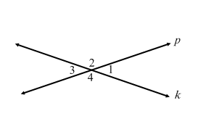

1. Complete the following proof:

Given: Lines *k* and *p* intersect at a given point.

Prove: 

**STATEMENT** **REASON**

**CORRESPONDING ANGLES POSTULATE:**

Given two parallel lines cut by a transversal, corresponding angles are ____________________.

**ALTERNATE INTERIOR ANGLES THEOREM:**

Given two parallel lines cut by a transversal, alternate interior angles are ___________________.

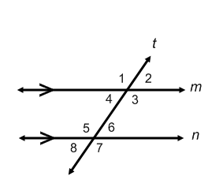

2. Given: Line *m* is parallel to line *n* with transversal *t*.

Prove: 

**STATEMENT** **REASON**

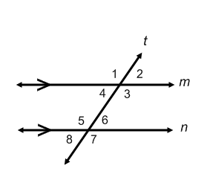

3. Given: Line *m* is parallel to line *n* with transversal *t*.

Prove: 

**ALTERNATE EXTERIOR ANGLES THEOREM:**

Given two parallel lines cut by a transversal, alternate exterior angles are ___________________.

4. Given: Line *m* is parallel to line *n* with transversal *t*.

 Prove: 

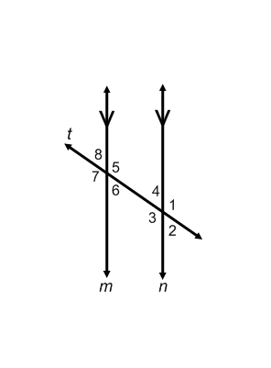

5. Given: Line *m* is parallel to line *n* with transversal *t*.

Prove: 

**SAME SIDE INTERIOR ANGLES THEOREM:**

Given two parallel lines cut by a transversal, same side interior angles are ___________________.



6. Given: Line *m* is parallel to line *n* with transversal *t*.

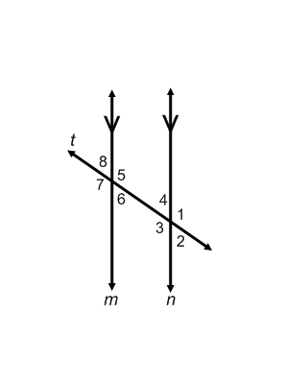 Prove: 